Lab Session – Day 13

**Question:**

Use classicmodels. For every orderNumber show the second highest quantityOrdered value.

Table: Orderdetails

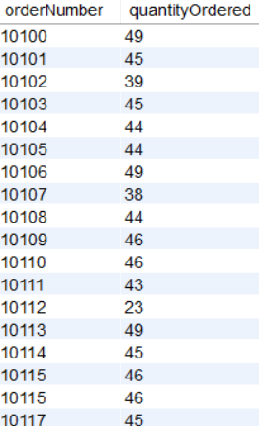The output should look as shown in below image.

**Solution:**

Write the below query in MySQL workbench.

